Final Exam Advanced Math for CS   
Josh Andre C. Timosan   
BSCS 3

# Manual Calculations:

## Matrix Inverse Method:

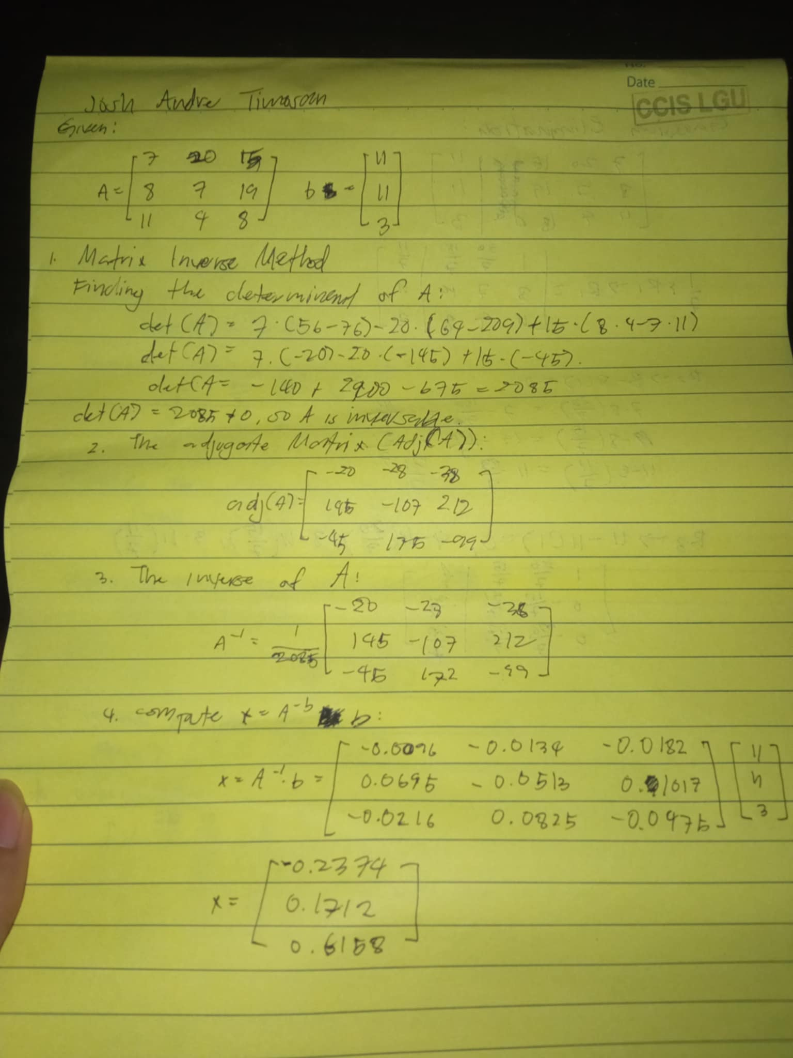

## c5e2a2f5-b327-461b-bcdc-74db3106e133Gaussian Elimination: